Award Winning Animation With Only 20 Lines Of CSS?

0:00
Camille normal you've got to be kidding
0:02
me you're too good at this I just don't
0:04
know how you possibly expect us regular
0:06
people to compete like I just can't
0:07
explain to you guys how smooth this
0:09
movement is unless you actually go to
0:11
this site and try it it's insane all
0:13
right I'm setting some limits so this
0:14
doesn't go on too long 10 lines of HTML
0:16
20 lines of CSS 30 lines of JavaScript
0:19
let's see how far we can get we'll start
0:21
with the body easy 100 this way 100 that

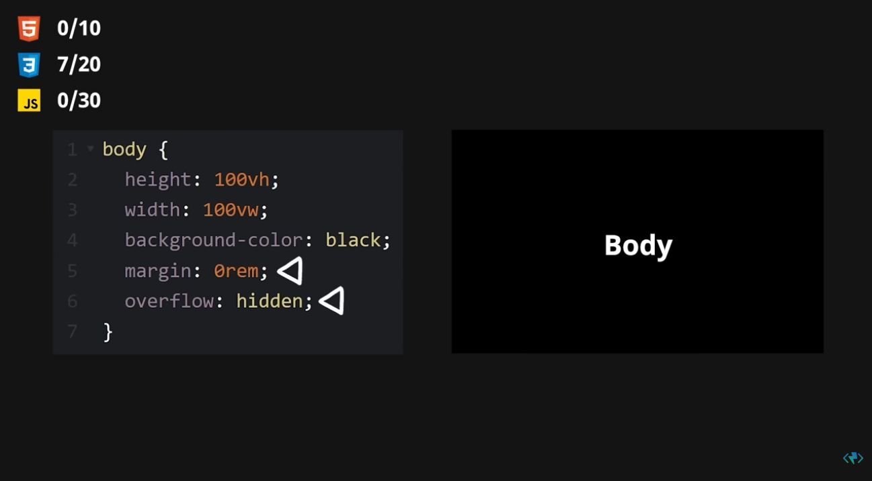
0:24
way black no scroll bars 7 out of 20
0:26
lines used these images got to be
0:28
contained in something let's call it a
0:30
track on splash.com copy paste repeat
0:33
seven more times 10 out of 10 lines used
0:36
we are done here let's fix these images
0:38
give them a width give them a height fix
0:40
the aspect ratio and Center it 14 out of
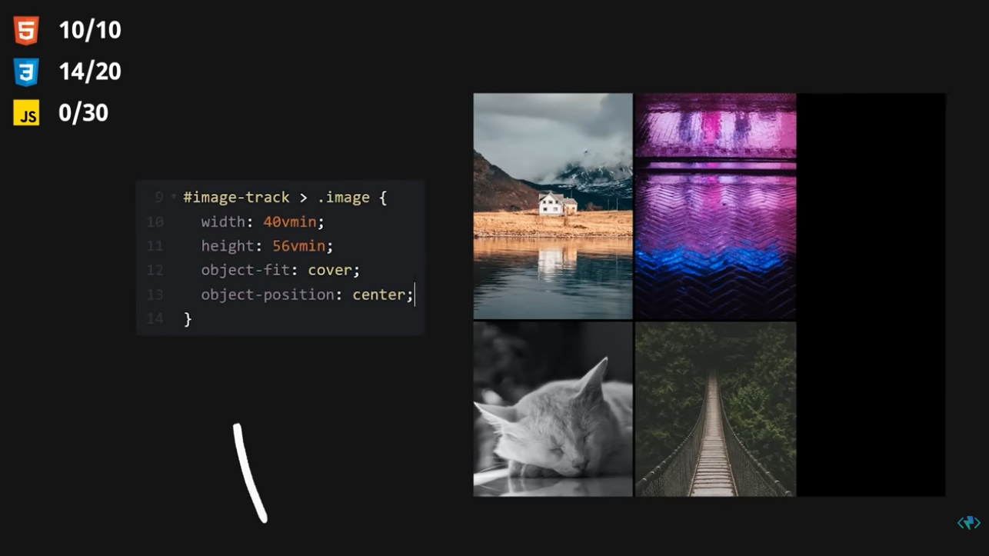
0:43
20 lines yikes okay gotta line them up
0:46
side by side display Flex add some space
0:49
between position absolute so I can set
0:51
the left and top positions to halfway
0:53
okay left looks good but top doesn't so
0:56
let's shift things up just a smidge oh
0:58
wow that's crazy I cannot believe
0:59
believe I somehow managed to keep that
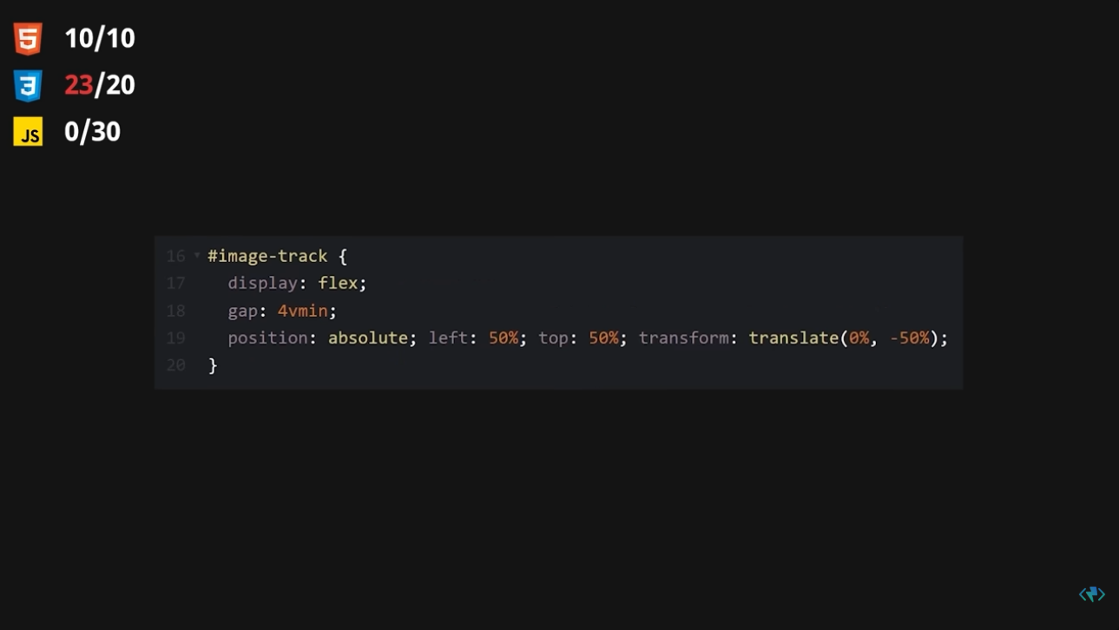
1:02
at 20 lines or less great job me all
1:04
right let's make this thing work I say
1:06
we start with a panning feature just
1:07
making it move left to right but wait I
1:10
can tell there's some trickiness going
1:11
on here because the images are moving at
1:13
a different rate of speed compared to
1:15
the track as a whole noted I don't know
1:17
much at this point but the one thing I
1:19
do know is that this effect is based on
1:21
Mouse movement when I press my mouse
1:22
down at any given point on the screen
1:24
and then drag in the Left Right
1:26
Direction the entire track is moving but
1:28
how do I know how far or how fast let's
1:31
see how far I have to drag to get from
1:32
one end of the track to the other aha so
1:34
by the time the mouse is halfway across
1:36
the screen the track has moved 100 of
1:39
its maximum distance so it's almost like
1:41
we can imagine there's a slider on the
1:42
screen and dragging it back and forth
1:44
controls our track but this slider is
1:46
extra fancy not only because it's always
1:48
following our Mouse around waiting for
1:50
us to click and drag but because it's
1:52
completely invisible as well so how do
1:54
we go about creating our magical
1:55
invisible slider well the very first
1:57
step to this interaction is pressing our
1:59
Mouse
2:00
so let's start by listening to any Mouse
2:02
down event that may occur when that
2:04
happens I know I want to keep track of
2:06
the exact X position the mouse was at so
2:08
we can use that as the starting point
2:09
for our invisible slider but where are
2:11
we going to store that value what if we
2:13
just created a new custom value on our
2:15
track element that will update every
2:17
time the mouse is pressed down all right

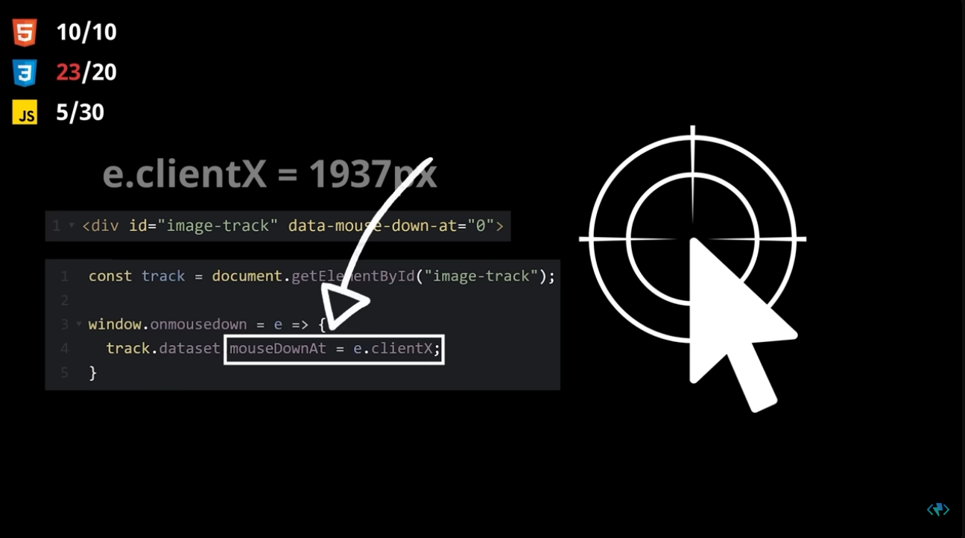2:19
what happens next step one was Mouse
2:21
down step two the mouse moves so we need
2:24
a mouse move listener we need a way to
2:26
know how far a mouse has traveled
2:27
relative to the starting point as well
2:29
as where the other end of our slider
2:31
should be the relative position is easy
2:32
enough just subtract the current
2:34
position from the starting point and we
2:36
already know the max distance is one
2:37
half of the width of the window so
2:39
dividing the relative position by the

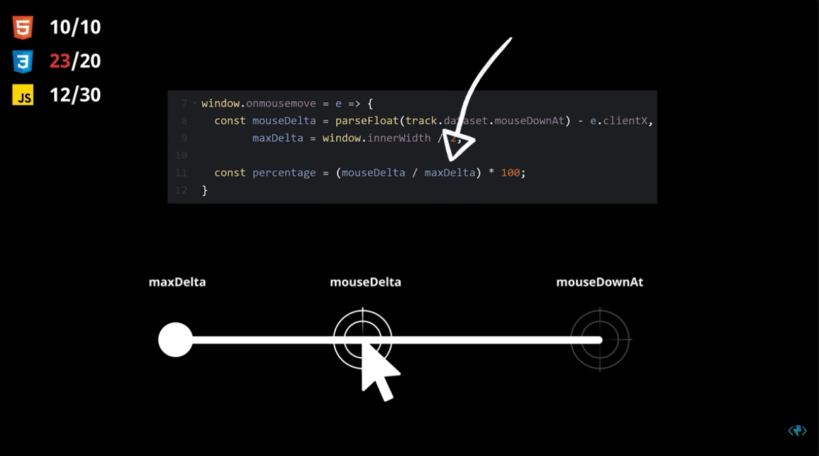2:41
max distance would convert this value to
2:42
a decimal and multiplying the decimal by
2:44
100 gives us a percentage oh wait my
2:47
head hurts why were we even doing this
2:49
again oh right because clicking and
2:50
dragging halfway across the screen has
2:52
to move our image track from one end all
2:55
the way to the other only this
2:56
functionality has to be possible no
2:58
matter where we click on the screen so
3:00
by track tracking the starting point and
3:01
using it to create a virtual slider
3:03
using math we can thereby obtain the
3:05
value we truly need which is the
3:07
percentage of our slider that has been
3:08
slid now if we recall earlier we use the
3:11
translate property to shift our slider
3:13
up by 50 of its height well thanks to
3:15
this value here we can perform a very
3:17
similar manipulation in the left right
3:18
direction for instance if we set this
3:20
value to negative 50 percent our track
3:22
moves fifty percent in the left
3:24
direction if we set it to negative one
3:26
hundred percent our track has moved all
3:27
the way to the opposite end fortunately
3:29
since we just spent all that time
3:31
calculating the percentage value of our
3:32
magic slider the next step is easy we
3:34
simply use this value to set the Left
3:36
Right percentage on our track and whoa
3:38
whoa hang on the mouse move listener has
3:41
no way of knowing when the mouse is
3:42
actually down so the track is moving
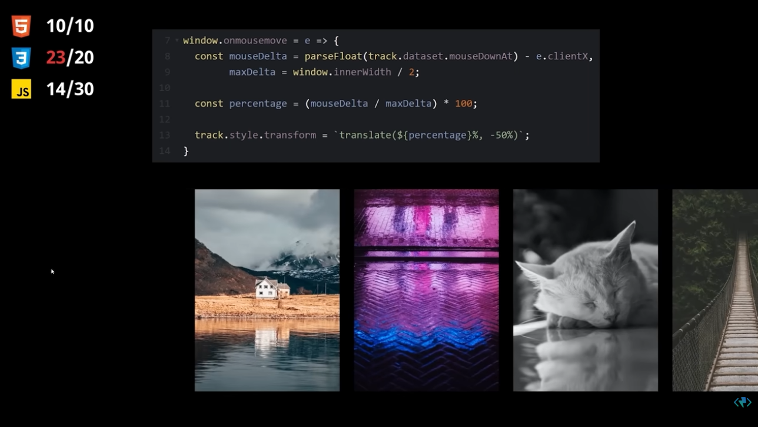
3:44
before it's supposed to well since I
3:46
know the mouse down at position is zero
3:48
before the mouse is pressed we could
3:50
just say that if that's the case return
3:52
immediately and skip the code that's
3:54
telling the track to move but as soon as
3:56
the user clicks the value will no longer
3:58
be zero so we'll have to set it back
4:00
back to zero when they release the mouse
4:01
okay so now when I click an image it
4:05
just drags It Off The Track stupid
4:07
default Behavior fine we'll just set
4:09
draggable to false okay no more weird
4:11
dragging but we're clearly going in the
4:13
wrong direction here so I guess we gotta
4:15
flip the sign all right looking good
4:17
here wait why is the position resetting
4:19
when I try to drag a second time are you
4:21
kidding since we're not keeping track of
4:23
how far we've dragged the slider instead
4:25
of continuing from where it was left off
4:27
it just resets back to zero fine okay so
4:30
just like we stored the mouse down
4:32
position with the track we're gonna have
4:33
to store the percentage there too I'm
4:35
guessing that way we can take the
4:37
current percentage slid and add it to
4:39
the last percentage to get the new
4:41
percentage so we need to store this
4:43
value every time they release the mouse
4:45
but how do we get that value from the
4:47
mouse move listener okay what if we
4:49
constantly update the percentage here
4:51
and then use it purely as a way to
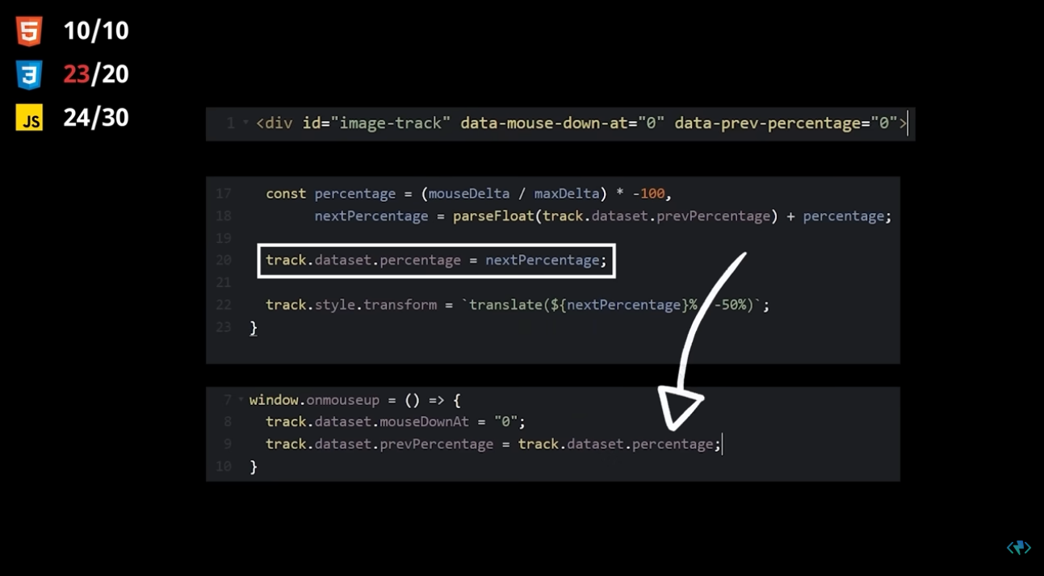

4:52
transfer the value between the two aha
4:55
there we go now when I click and drag a
4:56
second time it continues from where we
4:58
left off rather than resetting back back
5:00
to the default position of zero boy we
5:02
really got off in the weeds again there
5:04
what the heck just happened right so our
5:06
click and drag was technically working
5:08
but only if it was the first time the
5:10
user had ever moved the track what we
5:11
failed to account for was that the next
5:13
time the user decides to click and drag
5:15
their progress wasn't stored anywhere so
5:17
the track had no way of knowing it
5:18
should no longer start at zero by
5:20
constantly tracking the percentage and
5:22
storing it when they released the mouse
5:23
we can use that value as the new
5:25
starting point when determining the
5:27
percentage the next time phew okay now
5:29
our movement's solid but I'm noticing
5:31
our slider doesn't exactly have any
5:33
limitations at the moment as in I can
5:35
keep dragging it infinitely in either
5:36
direction so I'm thinking we gotta take
5:38
our next percentage value in combination
5:40
with the min max functions to set a
5:43
maximum value of 0 and a minimum value
5:45
of negative one hundred wait how many
5:47
lines are we at 24 not bad what's left
5:50
uh oh right that Parallax effect with
5:53
the images okay so here's what I'm
5:55
thinking as of now our images are
5:57
positioned in the center which
5:58
technically we can split into a vertical
6:00
Center and a horizontal Center and
6:03
really these values are just a nickname
6:04
for 50 but what if we start this one at
6:07
100 and then use the exact same
6:09
percentage value that we used for the
6:11
track to slide the image positions from
6:13
100 down to zero so all we have to do to
6:15
implement this is Loop over our images
6:17
replace the first value with next
6:19
percentage and since next percentage
6:21
runs from 0 to negative 100 we can just
6:23
add 100 to it to correct the range okay
6:25
it's definitely working correctly but it
6:27
just doesn't quite have that buttery
6:29
smooth feeling that Camille's did so
6:30
what if instead of updating the CSS
6:32
directly we gave them a little animation
6:34
instead let's replace the style updates
6:36
with the dot animate function we'll set
6:37
the duration to 1200 and the fill to
6:40
forwards so the animation is persisted
6:42
rather than the default behavior of
6:44
resetting after completion all right I
6:46
think we've passed our last line limit
6:47
so we better stop there take that
6:49
Camille just kidding you're awesome
6:51
thank you for inspiring us foreign
6:56
[Music]

